Emerging Leaders Program – Orientation Packet for Emerging Leaders

Program Purpose: NACADA needs diverse involvement and wants to support a variety of ways that diverse voices can be heard! NACADA wants all members to know that their voices count and can make a difference; their experience can play a role in shaping the association for years to come!

Program Objectives
- To identify potential local, regional, national, and international leaders from member groups who are UNDER-REPRESENTED in the association's leadership who are interested in LEADERSHIP DEVELOPMENT and LEADERSHIP INVOLVEMENT in the association.
- To identify Mentors from among experienced NACADA leadership to guide Emerging Leaders through a two-year leadership development program as they grow in their LEADERSHIP IN THE ASSOCIATION.
- To provide Emerging Leaders with a two-year leadership development program which will develop their LEADERSHIP SKILLS FOR THE ASSOCIATION.
- To provide opportunities for Emerging Leaders to reach out to colleagues and peers from under-represented groups and serve as Mentors to future NACADA leaders.
- To provide the support network needed and desired to foster a strong leadership development program for under-represented populations in our association.

Common Points of Confusion

Under-represented ≠ Minority

Under-represented = Percentage of that population in the leadership is not appropriately reflective of the percentage of that population in the membership.
Example: In 2015, in relation to gender, the overall NACADA membership was comprised of 21.37% male, 72.55% female, 0.03% trans, 6.05% N/A. At that time, the elected position leadership was 28.72% male, 70.21% female, 0% Trans, 1.06% N/A. Those figure indicate that, in 2015, female members, who comprised at least 72% of the membership but only 70% of the elected leadership, were slightly under-represented.

Minority = The smaller group in relation to the whole; a group distinguished from the more numerous majority.
Example: In 2015, using the figures stated above, we see that females were the majority NACADA member population, whereas members who identified as male or transgender were minority populations.

Minority and under-represented are two separate concepts that do not necessarily coincide. The above figures tell us that in 2015, while males were a minority member population, they were not an under-represented population.

The purpose of the Emerging Leaders Program is to assist members of any under-represented member population, whether they be minority or majority, to achieve appropriate representation in the leadership.

Leadership ≠ Involvement ≠ Professional Development

Involvement in the association is viewed broadly including leadership at many levels (within the division units, at the division level, at the Council level, at the Board of Directors level, and with the various work groups, ad hoc committees, and task forces), serving with the Consultant and Speaker Service, writing for a NACADA publication (such as the Journal, Academic Advising Today, and the NACADA Clearinghouse of Academic Advising Resources), or presenting at state, allied member, regional, annual, or international conferences.
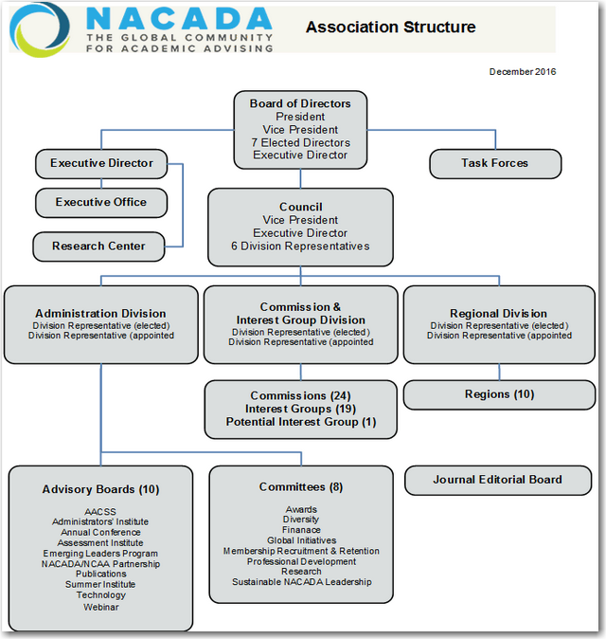

Find out more about the NACADA Leadership at http://www.nacada.ksu.edu/About-Us/NACADA-Leadership.aspx
- The chart above can be found by clicking on the “Organizational Structure” link in the left-hand navigation menu on that page.
- You can also find out more about the Board of Directors, Council, and the three NACADA Divisions from links there.
  - Another way to connect to the Divisions is under the “Community” tab at the upper right of the homepage: http://www.nacada.ksu.edu/

- Regional Division - The Regions facilitate networking and leadership opportunities, as well as professional development activities. They are governed by elected officers who propose activities within their geographic regions. Region members conduct annual conferences, state and province or area drive-ins, promote NACADA membership, and develop programs which fit the needs of their specific region.
- Commission & Interest Group Division - Provides opportunities to join others with similar academic or specific student population interests in advising.
- Administrative Division – Committees and Advisory Boards – do the administrative work of the association

More information about the purposes of the divisions and the important qualifications for leadership in each division can be found using the following interactive graphic, located at http://www.nacada.ksu.edu/About-Us/NACADA-Leadership.aspx

Working through this information with together with your Mentor might make a great initial exercise as you are getting acquainted!
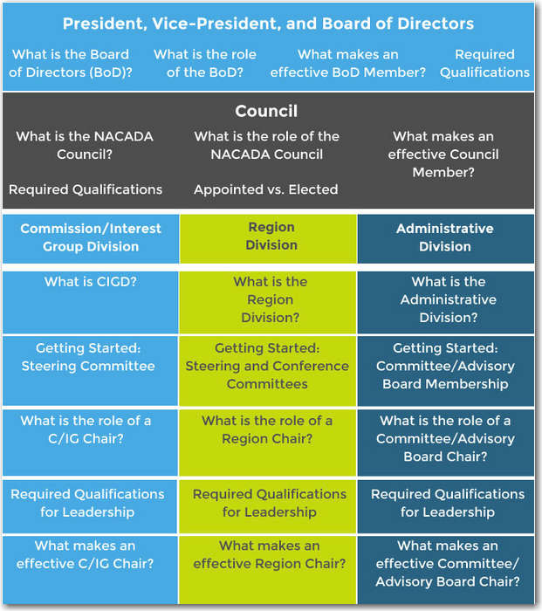

Common Competencies for NACADA Leaders
-- being developed by Sustainable Leadership Committee (from Casey Self video, 9/29/15)

- Each leader will understand the overall organizational structure of the Association and the Executive Office and be aware of the purpose of NACADA
  - How meetings are structured at conferences
  - Roles of the NACADA Board of Directors, Council, and three Divisions (http://www.nacada.ksu.edu/About-Us/NACADA-Leadership.aspx)
  - The four Pillar documents (find links to these at https://www.nacada.ksu.edu/Resources/Pillars.aspx)
    - Concept of Academic Advising
    - Statement of Core Values
    - Academic Advising Core Competencies
    - CAS Standards
  - The role of the Executive Office (http://www.nacada.ksu.edu/About-Us/Executive-Office.aspx)
- Each leader will understand the NACADA Strategic Plan and how each leader plays a key role in implementation of this plan (http://www.nacada.ksu.edu/About-Us/Vision-and-Mission.aspx)
- Each leader will develop leadership communication skills and strategies
  - Running meetings
  - Submitting reports
  - Staying connecting with individuals worked with on a regular basis
  - How to manage and coordinate volunteers
  - Time management
  - Electronic communication management
- Each new leader will understand the role and specific responsibilities of their elected, appointed, or volunteer position

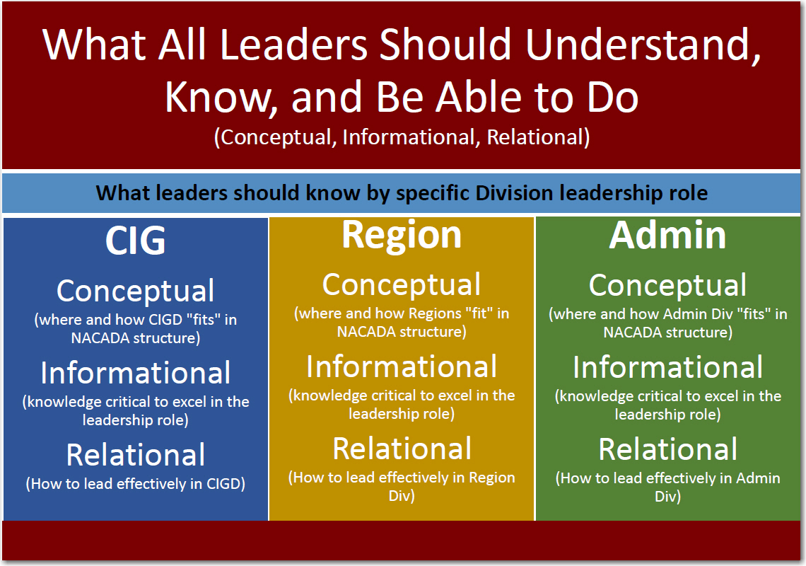

Scholarly Inquiry (Research) “Levels of Involvement and Experience”
NACADA views research as scholarly inquiry into all aspects of the advising interaction, the role of advising in higher education, and the effects that advising can have on students. It regards consuming and producing research as the collective responsibility of all members of the higher education advising community, including advisors, faculty, administrators, and students. (NACADA, 2008)

Please review the components of research experience and involvement below. Your understanding and development of these components will determine your current and future levels of involvement and experience with research.

LEVEL 1: Evidence-based Practice: Foundational Level (professional commitment)
  - (A) I agree with the statement above (NACADA, 2008) and understand that evidence informs practice, which leads to deeper knowledge about the components of student success and/or the context and theoretical bases of academic advising.

  - (B) I agree with the statement above (NACADA, 2008) and occasionally (or even regularly) read articles and consult resources related to student success or some aspect of academic advising.

  - (C) Occasionally (or even regularly) I implement what I’ve learned from the scholarly literature in my role with students. (May also be part of a team approach.)

  - (D) I am interested in conducting some type of research study, even a small-scale one, but am not sure how to go about the process of scholarly inquiry. I would like to be introduced to all components of the research process and possibly collaborate with others in some way.
LEVEL 2: Evidence-based Practice: Collaborative Level (active involvement)
2.1 (E) Observatory Level – I have been involved with a research study, but only as an interested observer, such as a:
- (a) Participant--so I have seen how the data collection and analysis process works…
- (b) Student (undergrad or grad) assistant--but not as the primary investigator…

2.2 (F) Conceptual Level - Still up for discussion, but I have:
- A general area of interest that has been identified…
- Possible research questions (if a social science design)…
- Theoretical framework in mind…
- Thinking about possible research designs…
- Have read some research articles related to my topic…

  - Operational Level – I’m set:
2.3.1 (G) – Proposed Study:
- A purpose of the study has been identified and research questions have been articulated…
- I have a theoretical framework in mind…
- My research design has been identified and proposed…
- I have conducted a review of related literature…
2.3.2 (H) – Completed Study:
- I have conducted a research study and am ready for more!
Please go to https://tinyurl.com/nacada-research-2017 to provide important feedback!

Executive Office Staff – Who can assist you with what!

Charlie Nutt – Executive Director
Cathy Swartz – Program Manager (Leadership elections and leader support, AACSS)

Administrative Team:
Maxine Coffey – Senior Associate Director (Liaison–Administrative Division)
Peggy Goe – Comptroller (accounting, investments, leadership support; Liaison–Finance Cmte)
Pam VanderPol – Accounts Receivable and Collections Manager
Bev Martin – Marketing Manager (publication sales and membership marketing)
Jackson Andre – Communications & Marketing Specialist
Cara Wohler – Office Manager

Event Planners:
Rhonda Baker – Assistant Director–Annual and International Conferences
Farrah Turner – Special Programs Coordinator (Annual and International Conferences)
Diane Matteson – Assistant Director–Regional Division (liaison, conferences)
Jennifer Rush – Program Manager (Winter events and Summer Institutes)
Dayna Kuhlman – Program Assistant (Conferences and Institutes)

Research Center:
Wendy Troxel – Director, NACADA Center for Research at Kansas State University; NACADA Journal Editor
Marsha Miller – Assistant Director–Resources (author support; Liaison–Publications Advisory Board)

IT:
Gary Cunningham – Senior Computer Systems Specialist (servers, network)
Michele Holaday – IT Support Specialist (website, social media, Highlights, NACADA Blog)

Content Team:
Jennifer Joslin – Associate Director–Content Development (Liaison–Administrative Division; eTutorials)
Leigh Cunningham – Assistant Director–Programs & Projects
Liaison–Professional Development Cmte, Inclusion & Engagement Cmte, Research Cmte
Web Events Producer
Emerging Leaders Program Coordinator
Managing Editor – Academic Advising Today and Pocket Guides
Dawn Krause – Content Program Coordinator
Liaison–Commission & Interest Group Division
Annual Awards Program Coordinator
NACADA Clearinghouse Coordinator
Internship Connection Service Coordinator
Elisa Shaffer – Project Manager–NACADA/NCAA Partnership

Find updated email addresses and direct phone numbers at http://www.nacada.ksu.edu/About-Us/Executive-Office/EO-Staff.aspx. Or, you can always dial 785-532-5717 to reach the main line.

Tips from “Those Who Have Gone Before”

Keep in mind throughout the partnering process (and beyond) that the purpose of the Program is to assist you in discovering NACADA Leadership opportunities and to develop the skills and tools needed to pursue those opportunities.
- If the work you and your mentor do in preparing for and seeking NACADA Leadership opportunities happens to also work positively towards your career aspirations and/or campus goals, that is a wonderful bonus – but promoting your career is not, in itself, the purpose of this program!
- Thus, the “ideal” match will be one in which the Mentor’s NACADA Leadership experience matches or exceeds your goals for NACADA Leadership (i.e., if your goal is to become a Region or CIG Chair, then the best Mentor would be someone who has served in that type of role; if your goal is to publish an article or manuscript in a NACADA publication, then the best Mentor would be someone who has authored a NACADA Journal article, monograph chapter, AAT article, etc.)

“Know Thyself” – Ask yourself these questions and consider the possible implications of your answers BEFORE coming to Orientation.
- What are my expectations of a relationship with a mentor?
- What personality characteristics do I have that are likely to affect how I relate with a mentor, and what characteristics do I need to look for that will go well with / complement mine? (i.e., if both are procrastinators, that may not be a productive match!).
- What type of time commitments are involved with my position? Are there busy times of the year that I am not available?
- When is the best time to contact me? What time zone am I in? Am I willing to be contacted outside my normal working hours?
- What is my preferred method of communication (Facebook, IM, e-mail, phone, text)?
- Do I have a clearly articulated vision of what my goals are for future NACADA leadership, or is that something I will need assistance with figuring out?
- Be ready to be upfront about your strengths, areas of expertise, time availability, etc., so that potential mentors can have clear expectations about how you will work together.

“Mine the Data” and Prepare for Orientation – Again, BEFORE coming to Orientation, spend the time to thoroughly research the available information in the “Summer Assignments” document.
- See what hints you can find in the responses that someone might or might not be a good match for you.
- If these responses spark any questions or there is something that you find intriguing in them, don’t hesitate to contact that person prior to the conference to seek more information. Our time together on Orientation day will pass by in what seems the blink of an eye!
- Develop a set of questions to ask potential mentors during the Orientation session that will help you determine whether that person will be a good match.
“For future program participants, I would push the importance of allowing the relationship to grow beyond the parameters of the program. The greatest benefits come from truly getting to know each other. Give of yourself and the returns will be immeasurable.”

Be Fully Present and Trust your Instincts
- Put your full energy into summer Zoom sessions and the “speed dating” process to ensure a good match.
- If “something tells you” that someone will not be a good fit for you, please be sure to make that known in the preferences sheet you will fill out.
- Once matched, don’t be afraid to really put yourself into the partnership; it can be scary letting someone you’ve only met once into your life, but it will be well worth it!

Mentoring Negotiating Questions and Outcomes for Mentors and Emerging Leaders

Outcomes | Questions Answered
Well defined goals | What are the specific learning outcomes desired from this relationship? For Mentor? For Emerging Leader? For NACADA?
Success criteria and measurement | What are the criteria for evaluating successful accomplishment of learning outcomes?  What is the process for evaluating success?
Delineation of responsibility | Who will be responsible for what?
Accountability assurances  - Relationships ground rules  - Confidentiality safeguards  - Boundaries | How do we ensure we do what we say we are going to do?  What are the norms and guidelines we will follow in conducting the relationship?  How do we protect the confidentiality of this relationship?  What are the “not to exceed limits” of this relationship?
Protocols for addressing stumbling blocks | What stumbling blocks might we encounter?  What process should we have in place to deal with them as they occur?
Agreement | What other considerations do we need to include to make this agreement work for us?
Work plan for achieving learning goals | What are the steps for achieving the learning goals?  What is the process?

Initial Conversations: My Goals

What I need to do | What this will help my mentor to do | How this will facilitate our mentoring relationship
Articulate what I want to learn from this experience | Determine your goals | Define if you are clear about your own goals and objectives
Articulate what I want out of the relationship | Determine your relationship needs and expectations | Make clear your needs or wants in the mentoring relationship
Define success and what it would look like | Decide if they have an area of experience or expertise that is relevant to your learning goals | Define the deliverables
Ask for feedback; discuss implications for the relationship | Determine their willingness/capability to contribute to the relationship | Candid sharing of assumptions, needs, expectations, and limitations
Decide how I would like to go about learning, articulate my learning and communication style, what kind of assistance I want, what types of projects/opportunities work best for me | Discuss options and opportunities for learning | Illuminate implications of each other’s styles and how that might affect the relationship

Setting SMART Goals

Specific: What exactly do I want to accomplish?

Measurable: How will I know when I have reached this goal?

Achievable: Is achieving this goal realistic with effort and commitment? Do I have the resources to achieve this goal? If not, how will I get them?

Relevant: Why is this goal significant to my development as a future NACADA leader?

Timely: When will this goal be achieved?

More Words of Wisdom from past Participants

Leaders and Mentors have a pretty big agenda over the next two years. They will be working hard on identifying and then meeting the goals that drew them to participate in the ELP in the first place. In addition, the Leaders will spend the last few months in the ELP program wondering “What’s next?” Leaders and Mentors will need to address:
- Building strong communication skills and creating a productive communication stream between one another right away. This terrific program and amazing opportunity begins and ends with successful oral and written communication skills. Leaders (and Mentors too!) need to develop a healthy skill set in this area;
- Information management questions. Early on Leaders will focus on learning about all the things they could do; very soon the issue becomes “what do I do with all of this information?”;
- Time management questions. “What are my priorities?” will be a question that remains throughout the ELP process. “How do I effectively meet the goals of the program during this period?” is another hot topic for discussion;
- Developing a healthy Leader-Mentor relationship. This relationship has the potential to be a pivotal and lifelong connection; Leaders and Mentors will need to be proactive should any issues arise;
- Transition and change issues. Just as this period is about transitioning into a pretty amazing program, in a few short years, Leaders and Mentors will be transitioning out of ELP and into a different relationship with one another. It is important that they talk about this transition before it arrives.

Recommendations:
- Understand the time that this will (should) require
- Intentionally plan, set aside, time right from the very beginning
- It is okay to start with several goals and then determine which are really important to you and which you want to eliminate
- Be mindful of your goals versus what might be externally-influenced goals
- Know that life and unforeseen circumstances may occur and alter the plan

“My advice for future ELPers is to encourage them to really reflect on what you want to accomplish and then GO FOR IT. Your mentor will help support what you want to do so you have to be thoughtful about what would be most important for you.”

Goals Development Process for Year One
(This sample form is for your benefit only. Please email just your goals to Leigh at Leigh@ksu.edu after you return home.)

- Identify Goals (the number of goals you set is up to you)
- Steps: What steps do you need to take to achieve each goal?
- Time Frame: What is your plan to complete these steps within the two year ELP time?
- Resources: What resources, including other people, will be needed?
- Outcomes: How will you know that each goal has been achieved?

Goal 1: ___________________________________________________________________________________________

Steps | Time Frame | Resources | Outcomes

Goal 2: ___________________________________________________________________________________________

Steps | Time Frame | Resources | Outcomes

Goal 3: ___________________________________________________________________________________________

Steps | Time Frame | Resources | Outcomes

SMART Goal Worksheet
(This sample form is for your benefit only. Please email just your goals to Leigh at Leigh@ksu.edu after you return home.)

Today’s Date: ____________________ Start Date: _______________________
Target Date: _____________________ Date Achieved: ___________________

Goal: ____________________________________________________________________________________________

Verify that the goal is SMART
Specific: What exactly will I accomplish?
____________________________________________________________________________________________________________________________________________________________________________________________________

Measurable: How will I know when I have reached this goal?
____________________________________________________________________________________________________________________________________________________________________________________________________

Achievable: Is achieving this goal realistic with effort and commitment? Do I have the resources to achieve this goal? If not, how will I get them?
____________________________________________________________________________________________________________________________________________________________________________________________________

Relevant: Why is this goal significant to my life?
____________________________________________________________________________________________________________________________________________________________________________________________________

Timely: When will this goal be achieved?
__________________________________________________________________________________________________

This goal is important because:
____________________________________________________________________________________________________________________________________________________________________________________________________

The benefits of achieving this goal will be:
____________________________________________________________________________________________________________________________________________________________________________________________________

Potential Obstacles Potential Solutions
_____________________________________________ _____________________________________________
_____________________________________________ _____________________________________________
_____________________________________________ _____________________________________________

Who are the people I will ask to help me?
__________________________________________________________________________________________________

Specific Action Steps: What steps need to be taken to get me to my goal?
Step Expected Completion Date Completed
____________________________________ ______________________________ __________ __________
____________________________________ ______________________________ __________ __________
____________________________________ ______________________________ __________ __________
Mentoring Partnership Agreement -
(This form is for your benefit only. Please email just your goals to Leigh at Leigh@ksu.edu after you return home.)

We have agreed on the following goals as the focus of the first year of our mentoring relationship:

1.

2.

3.

4.

We have discussed the protocols by which we will work together, develop, and in that same spirit of partnership, collaborate on the development of a work plan. In order to ensure that our relationship is a mutually rewarding and satisfying experience for both of us, we agree to:

- meet regularly. Our specific schedule of contact and meetings including additional meetings is as follows:

- look for multiple opportunities and experiences to enhance the emerging leader’s learning. We have identified and will commit to the following specific opportunities and venues for learning:

- maintain confidentiality of our relationship. Confidentiality for us means:

- honor the ground rules we have developed for the relationship. Our ground rules will be:

- provide regular feedback to each other and evaluate progress. We will accomplish this by:

We agree to meet regularly until we accomplish our predefined goals or for a maximum of two years. At the end of this period of time, we will review the agreement, evaluate our progress, and reach a learning conclusion. The relationship will then be considered complete. If we choose to continue our mentoring partnership, we may negotiate a basis for continuation, so long as we have stipulated mutually agreed on goals.

In the event one of us believes it is no longer productive for us to continue or the learning situation is compromised, we may decide to seek outside intervention or conclude the relationship. In this event, we agree to use closure as a learning opportunity.

______________________________ _______________________________
Mentor’s signature and date Emerging Leader’s signature and date

”Speed-Dating” Notes – Potential Mentors

What questions do you have for these potential mentors after reading their summer assignment responses?

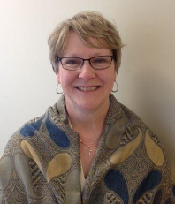
Nancy Roadruck (Assistant Director–College of the Arts Academic Advising, Kent State University, Kent, OH, Region 5)

David Spight (Director of Undergraduate Affairs, College of Engineering, University of California, Davis,
Region 9)

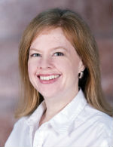
Amanda Mather (Assistant Director, Academic Services, Academic Services Office, Texas A&M University at Qatar, Region 7 and International)

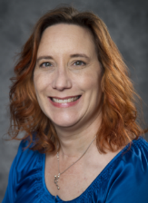
Amy Korthank (Academic Advisor, University of Iowa, Iowa City, IA, Region 6)

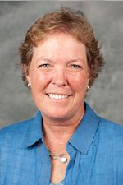

Wendy Troxel (Director, NACADA Research Center, Kansas State University, Region 7)

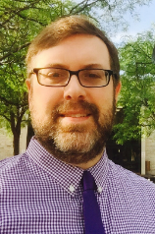
John Sauter (Assistant Dean for Academic Affairs, College of Arts & Sciences, Niagara University, Niagara University, NY, Region 1)

Leah Panganiban (Academic Services Program Manager, Global Innovation Exchange, Master of Science in Technology Innovation Program, University of Washington, Seattle, WA, Region 8)

Brandan Lowden (Coordinator of Advising, Pikes Peak Community College, Colorado Springs, CO, Region 10)

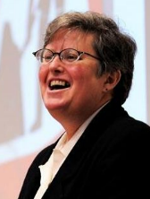
Jennifer Joslin (Associate Director for Content, NACADA, Kansas State University, Manhattan, KS, Region 7)

Kyle Ross (Academic Coordinator, College of Nursing, Washington State University, Spokane, WA, Region 8)

