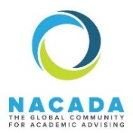
COMMUNITY NAME

Description: Lorem ipsum dolor sit amet, consectetur adipiscing elit, sed do eiusmod tempor incididunt ut labore et dolore magna aliqua. Ut enim ad minim veniam, quis nostrud exercitation ullamco laboris nisi ut aliquip ex ea commodo consequat.

Chair Name & Contact Info

Current HOT TOPICS in our area and one related article or resource:
- Topic 1
  - Resource 1
- Topic 2
  - Resource 2
- Topic 3
  - Resource 3

Two-Three things you need to know about working with COMMUNITY:
- Need to know 1
- Need to know 2
- Need to know 3

For more information check out our webpage at:
ENTER URL OF COMMUNITY

Connect with us on Social Media at:
fb.com/COMMISSIONNAME/

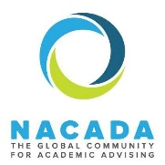
FIRST GENERATION COLLEGE STUDENT ADVISING COMMUNITY

Community description: This community identifies and addresses issues pertaining to first-generation (first gen) college students. Ongoing discussions focus on the definition of terms, ways of identifying first-generation students, and concerns particular to these students.

Lauren Szafranski, University of Wisconsin-Madison
lauren.szafranski@wisc.edu

Current HOT TOPICS in this area and one related article or resource:
- Understanding the needs of first-gen students:
  - NACADA eTutorial on Working with First-Generation Students
- How to encourage first-gen student success:
  - NACADA Clearinghouse page with over 30 resource links
    - (Enter “First-Generation Students Resources” in the Clearinghouse search)

Two things you need to know about working effectively with first-gen students:
- Understanding your campus’ first-gen student population can aid program design. What do you know about first-gen student success on your campus? What do you need to know to act?
- First-gen students can feel isolated. What resources does your campus have for first-gen students? How can you help all campus advisors learn about these resources?

For more information check out our webpage at: http://www.nacada.ksu.edu/Community/Commission-Interest-Groups/Advising-Specific-Populations-II/First-Generation-College-Student-Advising-IG.aspx

